**Families of Functions**

1. 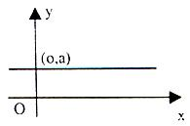Constant Function

Rule:

y = c

Example:

The admission fee at La Ronde is the same no matter how many rides

1. 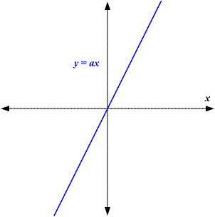Direct Variation Function

Rule:

y = ax

Example:

Paying $2 per ride with no entrance fee.

1. Partial Variation Function

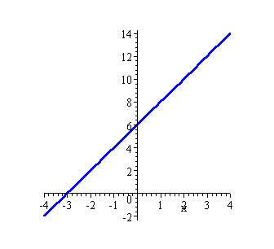

Rule:

y = ax + b

Example:

Paying $2 per ride plus a $10 entrance fee.

1. 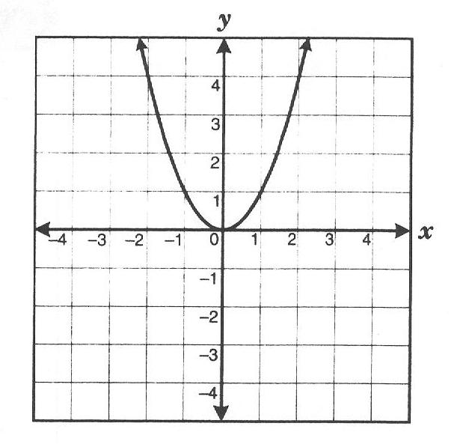Quadratic Function

Rule:

y = ax2

Example:

A ball being thrown in the air and it falling down.

1. Rational Function

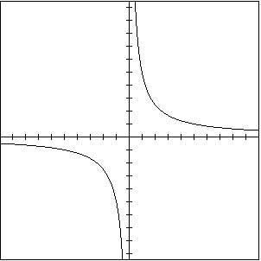

Rule:

Y = x / k

Example:

Rate of emptying a pool and the time it takes.

1. Exponential Function

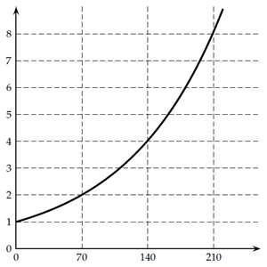

Rule:

y = acx

Example:

Accumulating interest in a savings account.

1. 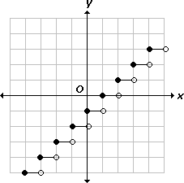Step Function

Rule:

n/a

Example:

Paying $3 for each hour in a parking garage

1. 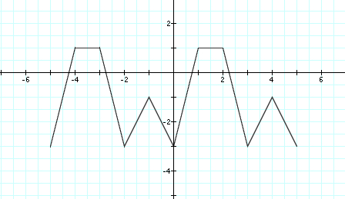Periodic Function

Rule:

n/a

Example:

Anything that repeats in cycles

1. 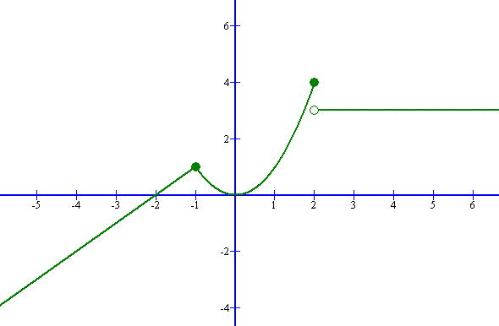Piecewise Function

Rule:

n/a

Example:

Cut and paste of different functions.