**Geometry Review**

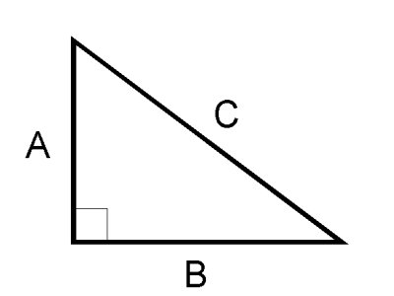**Triangles**

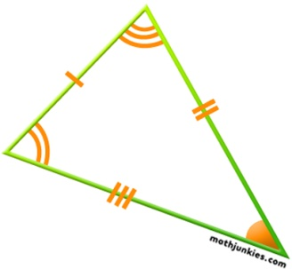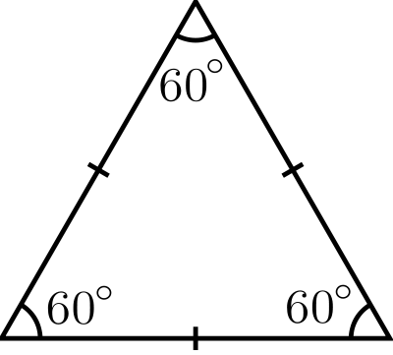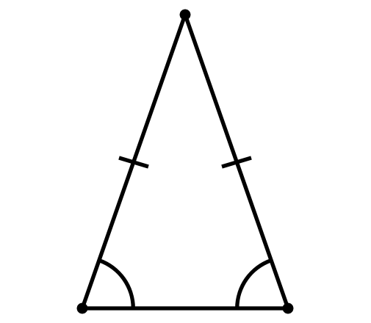

Isosceles

Equilateral

Scalene

Right

* Sum of all the angles in a triangle must equal 180°

**Pythagoras**

C2 = A2 + B2

A

B

C

c2 = a2 + b2

132 = 52 + b2

169 = 25 + b2

169 – 25 = b2

144 = b2

b= √144

b = 12

5

b

13

**Angles**

* 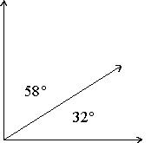Complementary Angles are 2 angles that add up to 90°

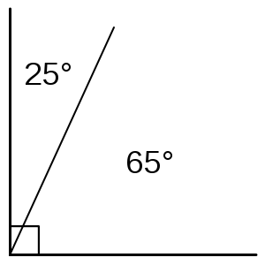

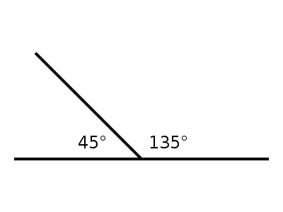

* Supplementary Angles are 2 angles that add up to 180°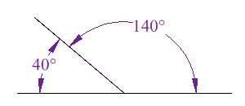
* 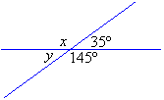Vertically Opposite Angles (VOA)

**Angles in Parallel Lines**

* 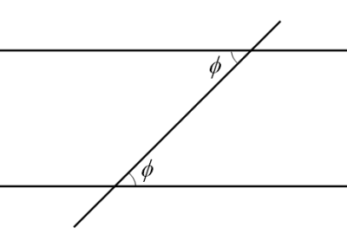Alternate Interior Angles Alternate Exterior Angles

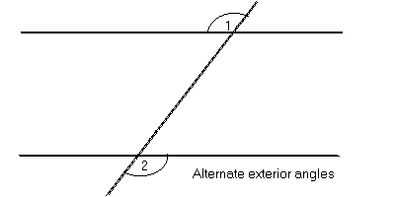

* Corresponding Angles

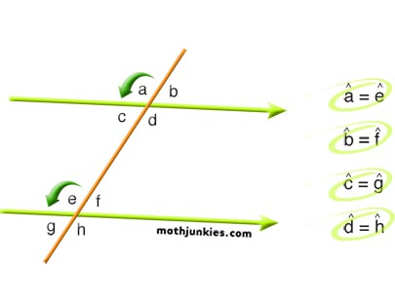

* Quadrilaterals

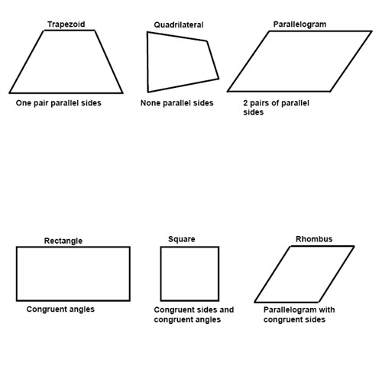

Supplementary adjacent angles – meaning that angles next to each other add up to 180

Sum of all angles = 360°