**Midpoint**

Given two points on the Cartesian plane, we want to know the coordinates of the point that is exactly halfway between them (midpoint)



*we are cutting the line in half*

*Example #1:*

Point A is located at (3,1) Point B is located at (9,-3)

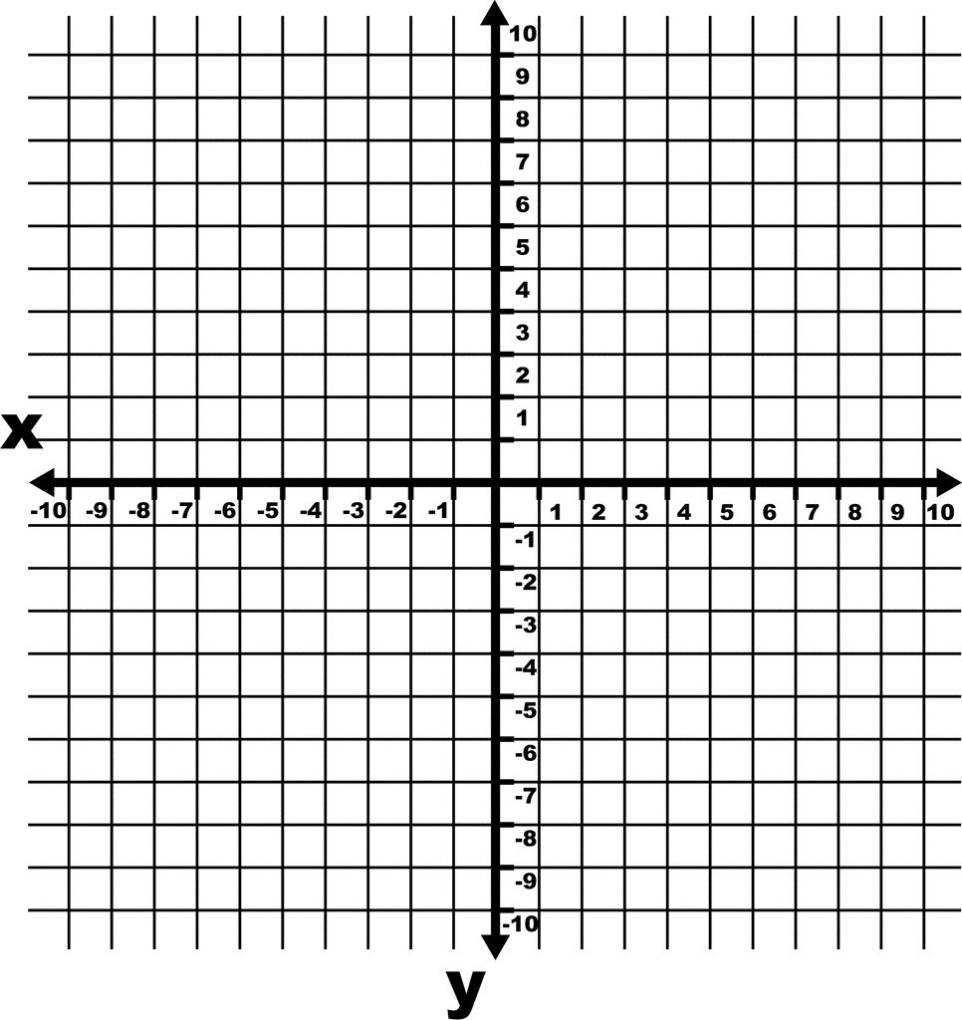

A (3,1)

B (9,-3)

Label the points as (x1, y1) and (x2, y2)

The formula that gives the coordinates of the midpoint is:

( (x2 + x1) , (y2 + y1) )

_______  
 2

_______  
 2

So, we calculate:



( 9 + 3 , -3 + 1 )

( 12 , -2 )

____  
 2

____  
 2

( 6 , -1 ) This would be the coordinates of our midpoint

*Example #2:*

Point A is located at (3,5) Point B is located at (1, 4)

*Step # 1 – Label the points*

A ( 3, 5 ) B ( 1, 4 )  
 (x1, y1) (x2, y2)

*Step #2 – Write the formula*

( (x2 + x1) , (y2 + y1) )

_______  
 2

_______  
 2

*Step #3 – Fill in the formula and calculate*

____  
 2

( 1 + 3 , 4 + 5 ) ( 4 , 9 )

____  
 2

____  
 2



____  
 2

Midpoint is located at ( 2 , 4.5 )