Similar Triangles
Find the scale factor or ratio of similarity:
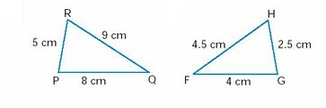

Ratio of Similarity (k) = $\frac{Image}{Original}$
K = $\frac{5}{2.5}$
K = $\frac{8}{4}$
K = $\frac{9}{4.5}$
}
2
Remember you need to compare the same sides in both triangles and check the ratios for each side. If they are all the same ratio, then the triangles are similar.

There are three theorems that can justify whether or not two triangles are similar:
Theorem 1 – Side Side Side (SSS)
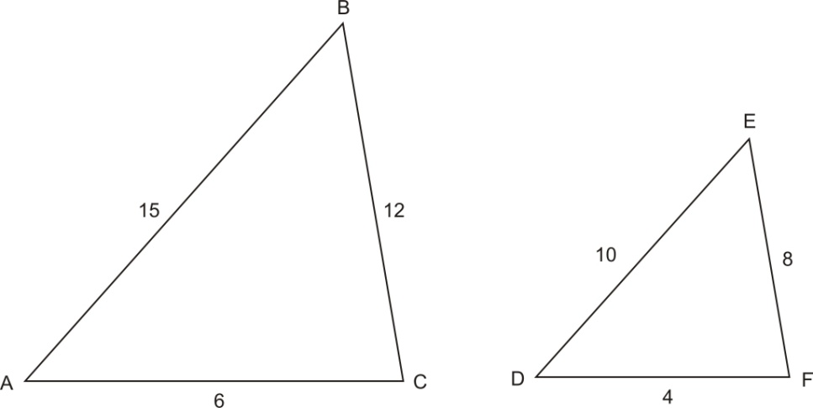
If the scale factor or ratio between all three corresponding sides is the same, the triangles are similar.
K = $\frac{DE}{AB}$ = $\frac{10}{15}$= $\frac{2}{3}$
K = $\frac{EF}{BC}$ = $\frac{8}{12}$= $\frac{2}{3}$
K = $\frac{DF}{AC}$ = $\frac{4}{6}$= $\frac{2}{3}$

Theorem 2 – Angle Angle (AA)
If a pair of triangles have two angles in common, they are similar.
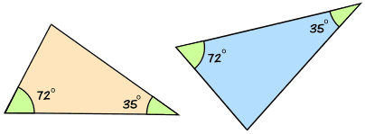
*Note – the sum of the interior angles in a triangle must add up to 180°
Therefore if two of the angles are the same, the 3rd is automatically the same

Theorem 3 – Side Angle Side (SAS)
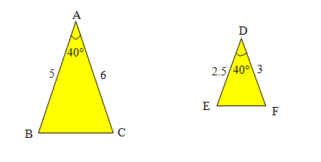
If one of the angles is the same in both triangles, and the ratio or scale factor between the two sides that form the angle (sandwich the angle) is the same, the two triangles are similar.
3 Checks:
k = $\frac{AB}{DE}$ = $\frac{5}{2.5}$ = 2
Angle A = Angle D
k = $\frac{AC}{DF}$ = $\frac{6}{3}$ = 2

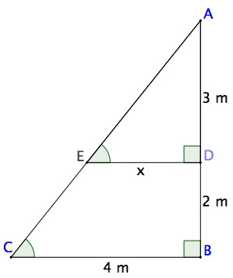
Finding Missing Measures
Example 1:
Step 1 – If you need to, re-draw both triangles side by side. Name
and label the triangles
A
A

3m

E
5m
x
D

4m
C
B

Step 2 – determine which sides are corresponding and set up a proportion to find the missing measure (cross multiply and divide method)
AB
___
AD
=
BC
___
DE

___
3m
5m
4m
___
x
=

5x = 12
X = 2.4

Example 2:
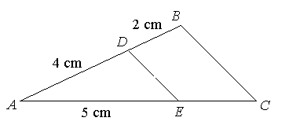
Find the measure of EC

x
A
D
E
5cm
4cm
B
C
A
6cm

AD
___
AB
=
AE
___
AC
___
6
4
5
___
x
=
4x = 30
X = 7.5
EC = AC – AE
EC = 7.5 – 5
EC = 2.5 cm

